# CSE 4308

## LAB 2 ASSIGNMENT

Task statement:

Our main goal for this task was to create a temporary username, create a table with 4 attributes and complete various operations using SQL commands from that table such as INSERT, SELECT, FROM etc. Using these commands, we inserted various information into the table and displayed them accordingly. After the completion of the tasks, we had to DROP the table or delete it.

Solution approach:

In order to solve these tasks, we first had to have an idea about absolute basic SQL commands. After learning these commands, it was relatively easy to solve them. I first typed out the commands in a notepad for easier execution later on. At first, I created a temporary username as instructed and connected to that account. After that I created a table using *CREATE TABLE TABLE_NAME{}* and initialized the attributes according to their datatypes. After that, according to the provided table, I inserted the information using *INSERT INTO TABLE_NAME (ATTRIBUTES) VALUES (VALUES_TO_BE_INSERT).* After that the third task was to display a bunch of information and I completed the task using commands such as *SELECT (ATTRIBUTES) FROM TABLE_NAME WHERE (CONDITION)* . After the completion of all the tasks, the last thing to do was drop the table, which as achieved with *DROP TABLE_NAME*. A snippet of the solution is provided below:

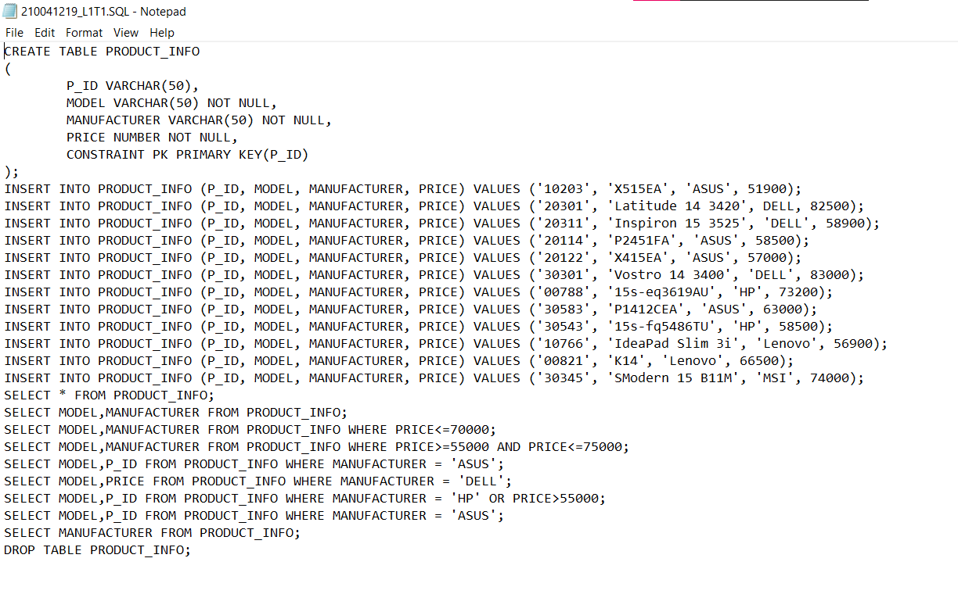

The commands that were used are:

CREATE TABLE:

The CREATE TABLE command is used to define and create a new table within a database. We specify the table's name and its columns, along with their data types and any constraints.

INSERT INTO:

The INSERT INTO command is used to add new records (rows) into an existing table. We provide the values for each column in the order they are defined in the table.

SELECT:

The SELECT statement is used to retrieve data from one or more tables. It allows us to specify which columns we want to retrieve and can include filtering, sorting, and joining multiple tables.

FROM:

The FROM clause is used in conjunction with the SELECT statement to specify the table or tables from which you want to retrieve data.

WHERE:

The WHERE clause is used to filter records based on a specified condition. It's commonly used with the SELECT statement to retrieve specific rows that meet the specified criteria.

DROP:

The DROP command is used to delete database objects such as tables, indexes, or entire databases. Be careful when using this command, as it permanently removes the specified objects and their data.

Problems I faced:

The main problem I faced was that I forgot to declare the P_ID as varchar instead of number. That way, I forgot to account for the leading zeros in some specific product id. Aside from that, I kept forgetting to put semicolons at the end of sentences.

SUBMITTED BY

MEHREEN HOSSAIN CHOWDHURY

210041219